Mother Wit by Irma Mae Rodgers Walker

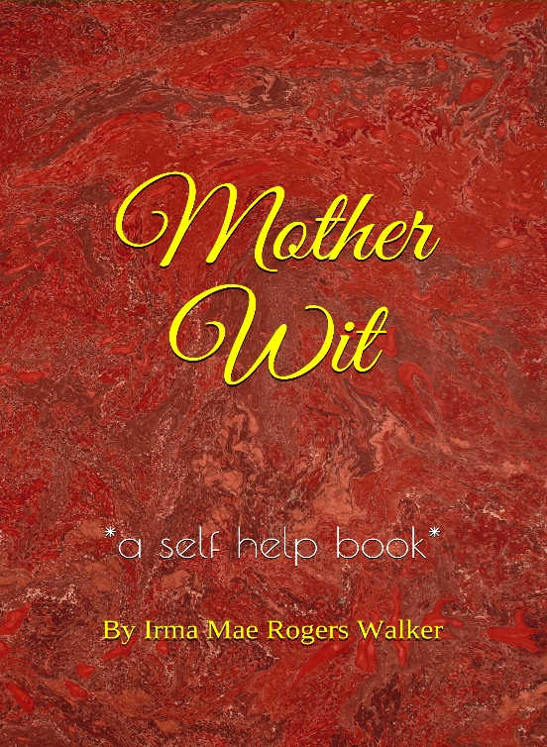
Jackson, MS — February 2, 2021 — Today, Meredith Etc proudly announces preorders for a new self-help book which offers readers advice about teenage pregnancy, parenting, marriage, relationships, and happiness based on the life lived experiences of the author. “Mother Wit … offers solutions to family units experiencing problems, declared William Trest Jr. Author at Meredith Etc.
“Ms. Walker, a family matriarch, is a talented and optimistic unlicensed counselor, Meredith Coleman McGee states. “Mother Wit is a testament of the value of a mother’s astute faculties,” McGee added.

Founded in February 2013, Meredith Etc is a small press with 25 print titles, eight audiobooks, and dozens of ebooks. “While Mother Wit was the only manuscript we acquired in 2020, it is a treasure and our first self-help book, “McGee proclaimed. “So far, advance readers love this book,” McGee added.

###
Softcover
For more information:

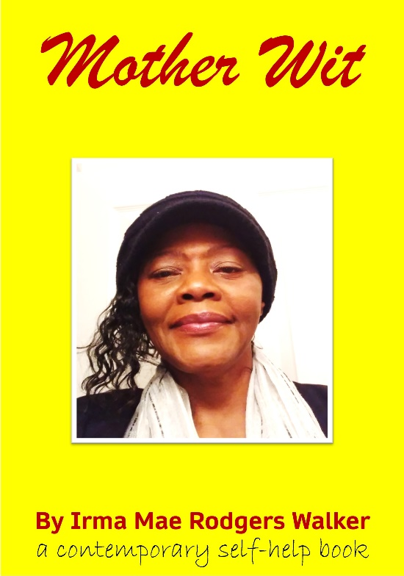
Meredith Etc
Meredith Coleman McGee,
Publisher/Acquisition Editor
1052 Maria Court
Jackson, MS 39204-5151
meredithcmcgee@gmail.com
601-372.0229

Mother Wit
6” x 9” Trade
88 pages
Genre: Self-help
softcover $7.74
hardback $13.98
ISBN-13: 979-8-7035005-1-4 softcover
ISBN-13: 978-1-7341578-6-4 hardback

https://meredithetc.com/mother-wit/ preorder page
Hardback

