GTo

Community Library Mississippi Goes Virtual

Community libraries & literacy
Library literacy efforts provide public spaces where families can spend time reading and learning together.

Children gain fluent literacy skills from school and from reading for pleasure. Research shows that student academic performance is higher among those whose parents read to them in their early school years (4 to 8).

The Community Library Initiative was formed by a small group of citizens in the fall of 2016 seeking to develop community led library programming designed to increase literacy, early learning, the love for reading, and provide spaces for intellectual exchanges and contests.
Community Library Initiative was renamed Community Library Mississippi. The organization incorporated March 21, 2019 as a non-profit corporation in Mississippi.
Mission Statement: To inspire intellectual growth through intellectual and cultural learning.

Purpose: Community Library Mississippi is a charitable organization formed to create neighborhood community library neighborhood spaces in Mississippi and to promote literary and intellectual programs.
Affiliate Groups/Programs

- Learning Tree Book Club
- Book Toasters
- Jackson Book Festival
- My First Book Series
- Reading Fairs
- Book give-a-ways (PreK - 1)
- Community Speaking Series
- Book Toaster’s Speaking Series
- Local History Speaker’s Series
- History Speaking Series

My First Book Series, 6 vols early learning activities & coloring books, 208 pages)

Black & white softcover edition …...$11.98

My 1 to 5 Activity Book Vol. 1, 42 pages
My A to G Activity Book Vol. 2, 21 pages
My H to P Activity Book Vol. 3, 49 pages
My 10 to 100 Activity Book Vol. 4, 31 pages
My 2 to 24 Activity Book Vol. 5, 36 pages
My Q to Z Activity Book Vol. 6, 56 pages
Single print books ……………………$5.38

My Picture Dictionary, July 2019 (PreK-1)

200 (3 & 4 letter word) images and definitions; back matter includes USA & world maps; lists fruits, vegetables, presidents, pronouns, seasons, vowels… Telling time chart… much more

Black & white softcover edition …….$5.98
Full color softcover edition ………..$14.98
Full color hardback edition ………..$16.78

Community Library Mississippi
Jackson, MS

10/03/2020
Volume 3, Issue 1

literacy
Reading Writing Speaking



Community Library Mississippi Goes Virtual
ZOOM online – Register on Eventbrite.com
Supported by the Mississippi Humanities Council

Learning Tree Book Club Meetings:
1st Saturdays 2 P.M. to 3:30 P.M. (Ages 6 to 60+)
●Nov. 7, 2020 ● Dec. 1, 2020 ●Jan. 2, 2021
●Feb. 6, 2021 ●Mar 6, 2020 ●April 3, 2020
●May 1, 2021 ●June 5, 2021 ●7-3 cancelled ●Aug. 7, 2021 ●Oct. 2, 2021 ●Nov. 6, 2021 ●Dec 4, 2021

Speaking Presentation & Book Festival/events

TUE. 10.06.2020 Art of Manuscript Writing
TUE. 10.13.2020 Teacher Family Relations
SAT. 11.28.2020 Virtual Holiday Book Festival
SAT. 11.28.2020 Spelling Bee (4 pm. 1st to 5th)
SAT. 11.28.2020 Poetry Contest 5 pm all ages
TUE. 12.01.2020 Black Poets, Then and Now
TUE. 12.08.2020 History of Book Marketing
TUE. 12.15.2020 5 for Twenty - Virtual Book 20

FACEBOOK
https://www.facebook.com/myfirstbookseries/ https://www.facebook.com/community.library.ms/
https://www.facebook.com/My-Picture-Dictionary-1144570515727430/

web/blog pages
https://shopheirs.com/community-library-ms/
https://meredithetc.com/community-library-ms/
https://meredithetc.com/learning-tree-book-club/
https://meredithetc.com/jackson-book-festival/
https://meredithetc.com/book-toasters/

CONTACT
Modern libraries have beanbag chairs, short shelves with book covers facing outward, prompting discovery, are family friendly, and are connected to parks, walking trails, retail space, outdoor decks, and other amenities.

Dolly Parton’s Imagination Library (literacy resource)
Dolly Parton’s Imagination Library is an important book gifting program that mails free, high-quality books to children from birth until they begin school, no matter their family’s income.

FACTS:
Local teachers are overburdened with students, subjects, and testing; they cannot lead literacy challenges on the local level by themselves.
Our national literacy crisis demands all hands-on-deck.
* * * * * * * * *
The beginning - First formal activity

Spring Break Reading Fair
MARCH 12-17, 2018, 8 A.M. – 4 P.M.
Pearl St. A.M.E. Church, Robinson Rd.
Pizza & Award Party: Fri. 2–4 P.M.

Email: communitylibrary.ms@gmail.com
Mailing Address: 1052 Maria Court
City/State: Jackson, MS 39204
Phone: 601.372.0229

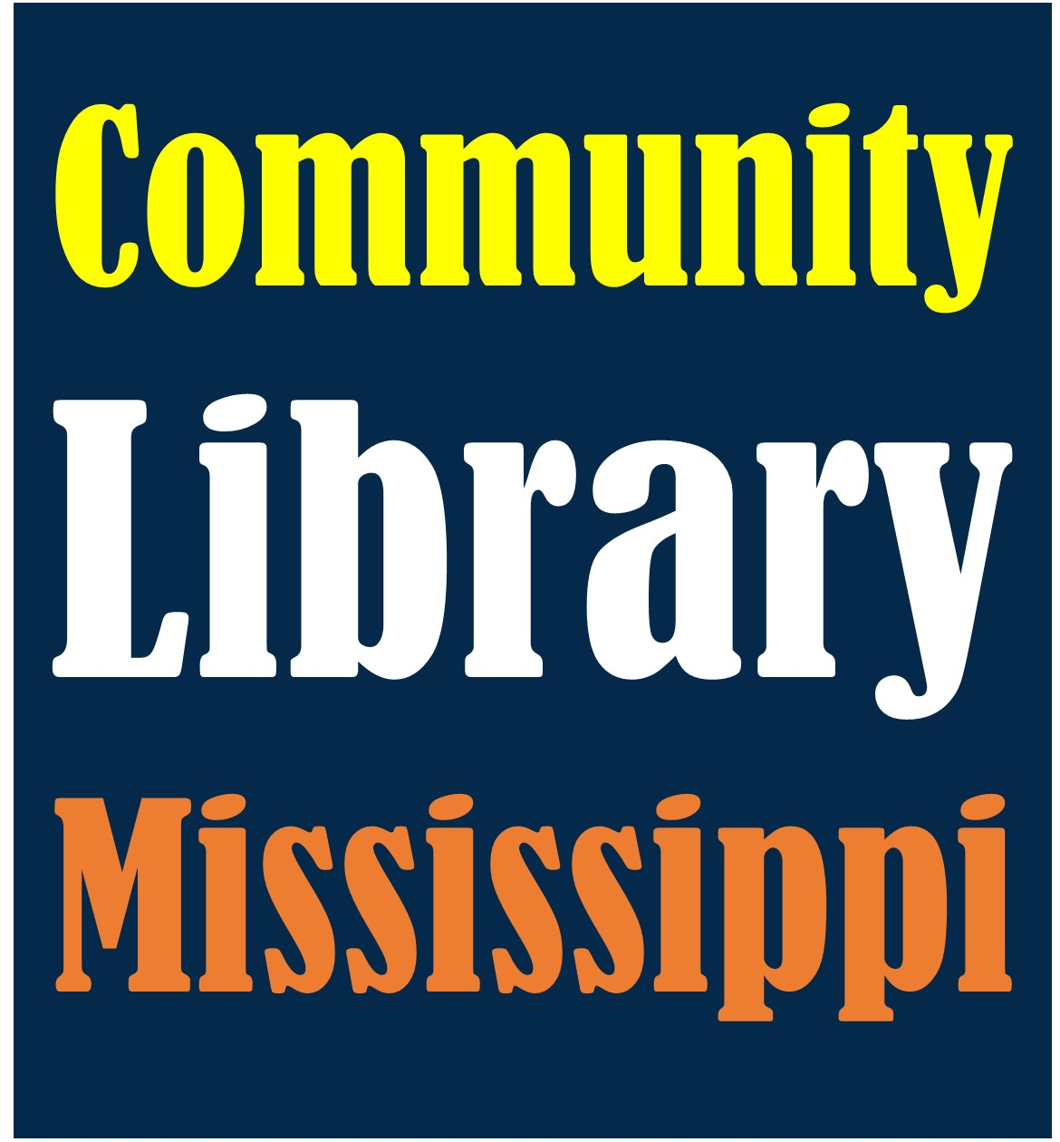

Modern libraries

Community Library Mississippi Newsletter Page 2

